3D Milk Industry Simulation — Research & Plan
Oct 10, 2026 · @Jojo

Goal & scope
Build a browser-based 3D simulation in Three.js of a UHT milk plant that runs all 10 stages, from standardization to ambient distribution, with animated equipment and live process data, over a 12-week term.
What the viewer sees and does
- Follows milk from the raw-milk silo to a delivery truck through one connected 3D plant.
- Reads live values at each stage: temperature, pressure, flow rate, tank level, packs and pallets counted.
- Changes a setting (UHT temperature, filler speed, QA result) and watches the plant react.
In scope
- One product: whole UHT milk (3.5% fat) in generic 1-litre aseptic brick cartons.
- Simplified physics: mass balance, temperature profile and timing that are believable, not engineering-grade.
- A time-speed control, so a 7-day quarantine and weeks of warehousing pass in minutes.
- Six fault scenarios with visible consequences, listed under Simulation model.
Out of scope (stretch goals at most)
- Fluid dynamics (CFD), detailed heat-transfer equations, fouling chemistry.
- Farm collection and raw-milk intake testing; the model starts at the raw-milk silo.
- Cleaning-in-place (CIP) cycles beyond a status light.
- Real brands, VR and mobile layouts.
Assumptions: one developer, desktop browser (Chrome or Edge).

The UHT line at a glance
The 10 stages form one line with a single hand-off: at the aseptic tank, flowing milk becomes packs you can count, track and hold.
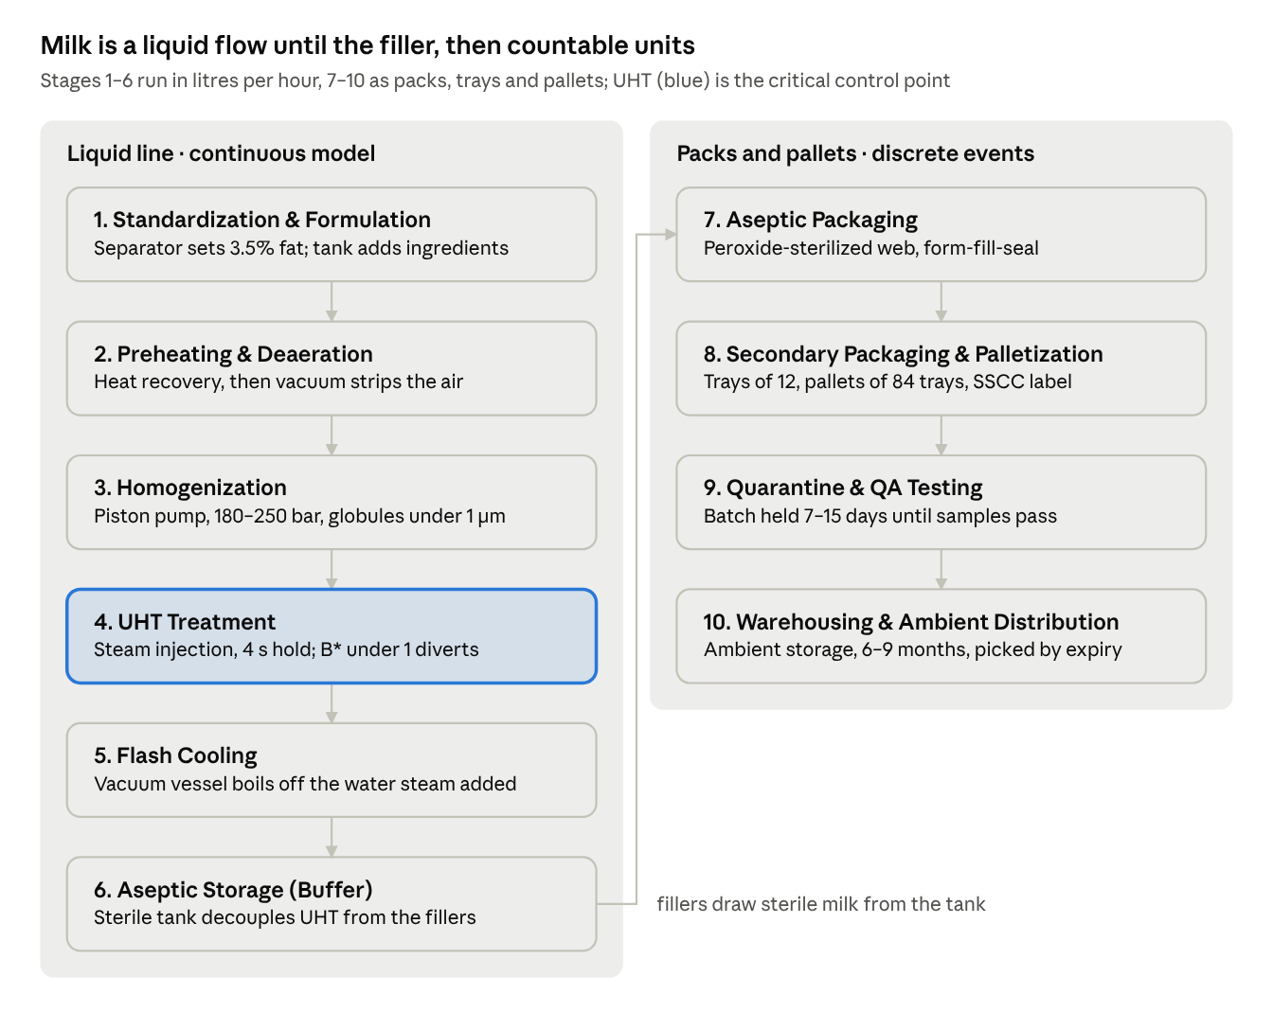
process flow · 10 stages, one hand-off
UHT is the critical control point: when the sterilizing effect drops, milk is diverted before it reaches the tank.
3D preview: UHT Milk Plant Preview runs this flow in the browser with grey-box models, example data, speed controls and three fault scenarios.
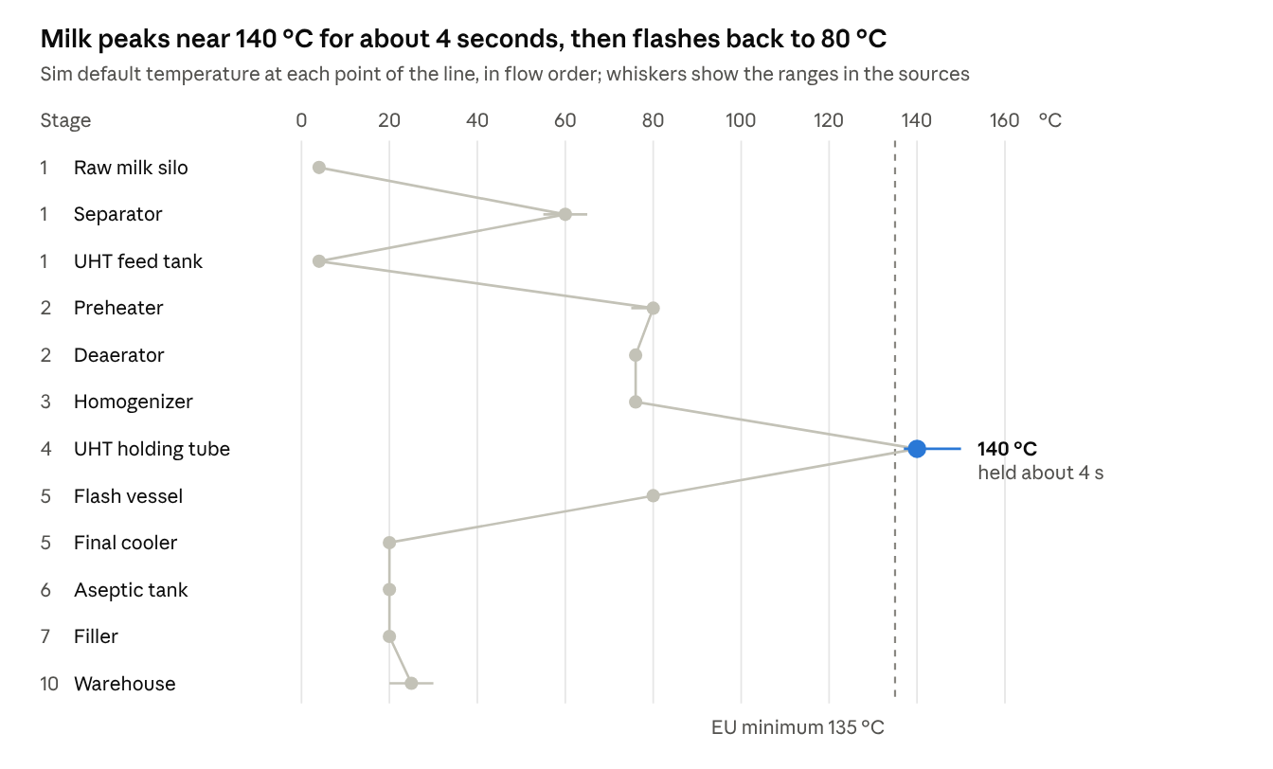
sim defaults and source ranges · Tetra Pak handbook, Regulation 853/2004, GEA
The sim uses the dots as set points and colours each pipe from them; the separator step sits in the upstream milk-treatment line, before the milk is cooled and stored for UHT.

Stage research 1–5: the liquid line
Stages 1–5 are one continuous flow of liquid, so the simulation tracks them in litres per hour, temperature and pressure.

1. Standardization & Formulation
A separator splits warm milk into skim and cream, and in-line control remixes just enough cream to hit the target fat (3.5% here).
- Real process: Raw milk waits in insulated silo tanks of 30,000–250,000 L with side agitators (Tanks). At 55–65 °C a disc-stack separator gives skim milk (about 0.05% fat) and cream (35–40%). Flow and density transmitters drive a valve that remixes cream, holding fat within 0.015% (Separators and standardization).
- Formulation: stabilizers, vitamins or flavours go in through batch tanks of 250–10,000 kg or in-line mixers; high-shear mixers handle hard powders (Mixers).
- 3D: silo with level gauge, separator with a spinning bowl, standardization skid (flow meters, valves), mixing tank with a turning agitator.
- Simulate: fat % by mass balance, surplus cream (L/h), silo and mix-tank levels, recipe per batch.

2. Preheating & Deaeration
Heat exchangers warm the cold feed to about 75–80 °C, then a vacuum vessel strips out the air.
- Real process: Milk leaves the feed tank at about 4 °C, passes a balance tank and feed pump, and is preheated to about 75 °C in indirect plants, using heat recovered from outgoing milk, or about 80 °C in direct plants (Long-life milk). In the deaerator, vacuum makes the milk boil 4–5 °C below its preheat temperature; a vacuum pump removes the air and a built-in condenser returns the vapour (Deaerators).
- Why it matters: air fouls heating surfaces and skews flow measurement (Deaerators).
- 3D: balance tank, feed pump, plate or tubular heat exchanger, vacuum vessel with condenser on top and a vacuum pump beside it.
- Simulate: outlet temperature from the set point, the 4–5 °C drop in the vessel, air content falling (a sim value), heat recovered in kW.

3. Homogenization
A high-pressure piston pump forces milk through a gap of about 0.1 mm, so fat globules shrink below 1 µm and no cream layer forms during months on the shelf.
- Real process: UHT lines homogenize at 180–250 bar (Long-life milk). The pump has 3–5 pistons; the first stage breaks the globules (about 3.5 µm down to under 1 µm), and the second adds about 30 bar back-pressure to break clusters. It runs at 55–80 °C, and every 40 bar of pressure drop adds 1 °C (Homogenizers).
- Position note: your stage order puts homogenization before UHT, as indirect plants do. Direct plants with flash cooling use an aseptic homogenizer after the flash vessel instead (Homogenizers).
- 3D: box-shaped machine with three pistons driven by a crank, two pressure gauges, motor with belt drive.
- Simulate: stage 1 and stage 2 pressures, temperature rise, globule size, a creaming-risk score, power draw (handbook example: 68 kW for 10,000 L/h at 200 bar).

4. UHT Treatment
Steam heats the milk to about 140 °C, a holding tube keeps it there for about 4 s, and any drop below the set point diverts the flow to reject.
- Real process: milk needs 135–150 °C for a few seconds, in practice 137–142 °C for 4–6 s (Long-life milk); EU law requires at least 135 °C (Regulation 853/2004, Annex III §IX). Direct plants inject steam through a ring nozzle to 140–150 °C, under pressure so it cannot boil. The target is a 9-log kill of heat-resistant spores (B* above 1) and an F0 of 5–6 min (UHT milk module).
- Safety logic: temperature is recorded at the holding-tube outlet (FDA aseptic guide). If it drops, product goes to a reject tank, and the plant is flushed, cleaned and re-sterilized before restart. Before each run, hot water at 125 °C or more circulates for at least 30 min (Long-life milk).
- 3D: steam injector head, coiled holding tube, flow-diversion valve with a green/red light, steam pipe from the boiler house.
- Simulate: holding time = tube volume ÷ flow, live F0 and B*, divert events, plant capacity (direct systems run 2,000–45,000 L/h).

5. Flash Cooling
A vacuum vessel drops the milk from about 140 °C to about 80 °C almost instantly and boils off the same amount of water the steam added.
- Real process: the vacuum is set so the vapour flashed off equals the steam injected, and the milk falls back to its preheat temperature, about 80 °C. A pump then feeds the aseptic homogenizer, and a tubular cooler brings the milk to about 20 °C for the aseptic tank or filler (Long-life milk).
- 3D: tall vessel with a conical bottom, vapour pipe to a condenser, extraction pump, tubular cooler.
- Simulate: water removed = steam added (solids stay constant), temperature steps to 80 °C and then 20 °C, condenser load.

Stage research 6–10: from sterile tank to truck
After the aseptic tank, milk becomes countable units (packs, trays, pallets), so the simulation switches from flow rates to discrete events.

6. Aseptic Storage (Buffer)
A sterile tank sits between the UHT plant and the fillers, so either side can stop or slow down without stopping the other.
- Real process: the tank balances supply to one or more fillers. The UHT plant is sized slightly larger, so the level builds up and the fillers keep running through its 30-minute intermediate clean; indirect plants can also run at 50–100% of capacity (Long-life milk). A Tetra Alsafe tank holds 7,000–50,000 L, is steam-sterilized at 125 °C or more, and keeps sterile air above the milk at up to 3.0 bar; a load cell in one leg weighs the contents.
- Rule: sterile-air overpressure must be kept during operation, and a failed air filter counts as a process deviation (FDA aseptic guide).
- 3D: vertical tank on three legs, valve cluster, sterile-air filter housing, floating level label.
- Simulate: level changes by (inflow − outflow) each tick; high level throttles the UHT plant to 50%, low level pauses the fillers; headspace pressure.

7. Aseptic Packaging
The filler sterilizes the carton material, forms it into a tube, fills it with sterile milk and seals each pack below the liquid level, so no air or germs get in.
- Real process: material comes off a reel and a plastic strip is sealed to one edge. The web runs through 30–35% hydrogen peroxide, then hot air at 60–125 °C removes the residue. It is formed into a tube, sealed lengthwise, and sealed across below the product level (ICPE aseptic packaging notes); the tube is then cut and folded into bricks.
- Example machine: the Tetra Pak A3/Flex fills up to 8,000 packages per hour in 500–2,000 ml formats, with a peroxide bath and a sterile-air zone under closed-loop control. US rules cap peroxide at 35% and residues at 0.5 ppm (UHT milk module).
- 3D: filler cabinet with a glass aseptic zone, paper reel, vertical tube, moving sealing jaws, outfeed conveyor of cartons.
- Simulate: packs per hour, random stops (time between failures, repair time), rejected packs, batch and date code on every pack.

8. Secondary Packaging & Palletization
Conveyors group packs into shrink-wrapped trays, and a palletizer stacks the trays into labelled pallets, the unit tracked from here on.
- Real process: downstream machines add straws to small portion packs, at up to 40,000 packs per hour (Straw applicators), and shrink-wrap trays. The Tetra Pak Tray Shrink 30 takes 40 tray sizes and 40 µm film, and speeds up by as much as 30% to clear a queue after a stop.
- Pallet label: each pallet gets an 18-digit SSCC; the GS1 label also shows product GTIN, quantity, batch number and best-before date (GS1 UK).
- 3D: conveyors with an accumulation table, tray-shrink tunnel, robot-arm palletizer, stretch wrapper with a rotating arm, label printer.
- Simulate: 12 packs per tray and 84 trays per pallet (sim assumptions, about 1,000 L), conveyor queues, catch-up speed after stops, one SSCC per pallet.

9. Quarantine & Quality Assurance Testing
Every batch stays on hold until its sample packs pass incubation, so a pallet can be finished but not yet sellable.
- Rule: EU law requires UHT products to stay microbiologically stable after 15 days at 30 °C or 7 days at 55 °C in closed containers (Regulation 853/2004, Annex III §IX). US rules do not make incubation mandatory, but inspectors check sampling, incubation conditions and lot acceptance criteria when it is used (FDA aseptic guide).
- Checks after incubation: colony count, pH and acidity change, smell and taste, ethanol stability; in one study a resazurin test caught every spoiled sample after 3 days at 30 °C (Journal of Dairy Research, 1990). The typical microbial failure rate is about 0.02% (UHT milk module).
- 3D: quarantine zone with yellow floor lines and a status lamp on each pallet, QA lab with incubators and sample packs.
- Simulate: samples per batch, incubation timer (time-compressed), pass or fail drawn from a failure rate, status HOLD → RELEASED or BLOCKED.

10. Warehousing & Ambient Distribution
Released pallets are stored and shipped at room temperature with no cold chain, and are picked by best-before date.
- Real process: UHT milk keeps six to nine months at 20–30 °C without refrigeration (GEA). Its shelf life ends through physical and enzyme changes such as creaming and gelling, not microbes; the handbook's examples are 3 months for local sale and 9 months for export (Long-life milk).
- 3D: pallet racks, forklifts or AGVs on floor paths, loading dock, truck that leaves when full.
- Simulate: stock by batch and best-before date, first-expired-first-out picking, random daily orders, truck dispatch, order fill rate.

Plant layout & 3D asset list
Lay the plant out as one U-shaped flow through seven zones, block everything out with simple shapes first, and spend real modelling time only on four hero machines: separator, homogenizer, filler and palletizer.
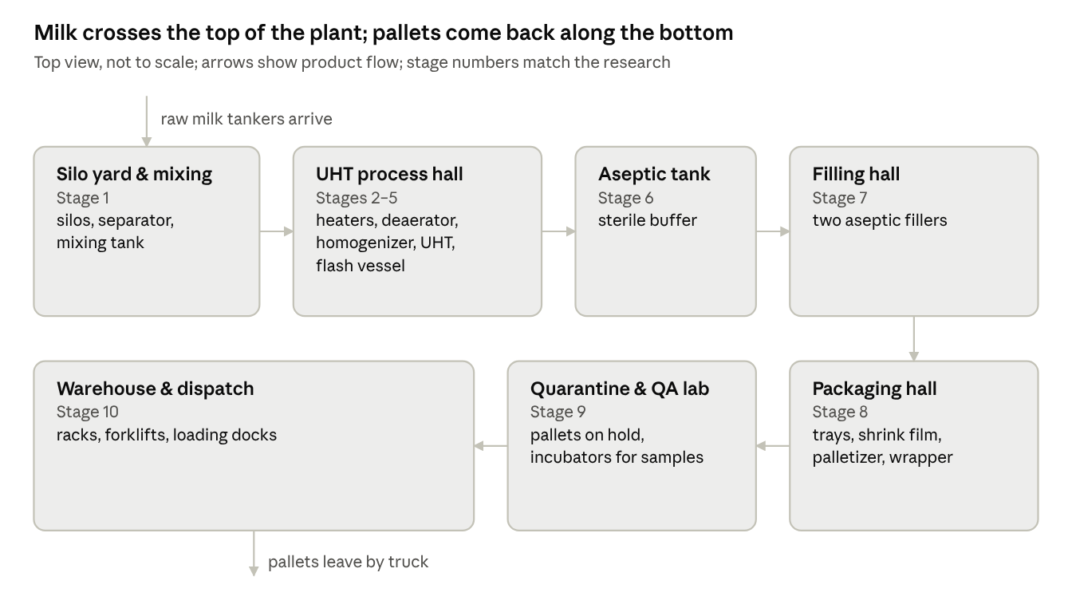
floor plan sketch · 7 zones, not to scale
The U shape lets the guided tour follow the product in one loop and keeps quarantine right next to the warehouse.
Asset | Stage | Build with | Animation | Priority
Raw-milk silos (2) | 1 | Code: cylinders | Level rises and falls | Must
Separator | 1 | Blender (hero) | Bowl spins | Must
Mixing tank with agitator | 1 | Code: cylinder + shaft | Agitator turns, level | Must
Standardization skid | 1 | Code: pipes, small boxes | Valve opening % | Should
Balance tank, pumps | 2 | Code | Impellers spin | Should
Plate heat exchanger | 2 | Code: instanced plates | Glows by temperature | Must
Deaerator with condenser | 2 | Code: cylinders | Bubbles rise | Must
Homogenizer | 3 | Blender (hero) | Three pistons pump | Must
Steam injector, holding tube | 4 | Code: TubeGeometry helix | Heat colour, steam puffs | Must
Flow-diversion valve, reject tank | 4 | Code | Valve flips, red light | Must
Flash vessel, tubular cooler | 5 | Code | Vapour plume | Must
Aseptic tank | 6 | Code: cylinder on three legs | Level and pressure | Must
Aseptic fillers (2) | 7 | Blender (hero) | Reel turns, jaws seal, packs exit | Must
1 L carton, tray, pallet | 7–10 | Code: boxes + generic texture | InstancedMesh movement | Must
Conveyors, accumulation table | 7–8 | Kenney Conveyor Kit (CC0, 60+ models) | Belt texture scrolls | Must
Tray-shrink tunnel | 8 | Code: box tunnel | Trays pass through | Should
Palletizer robot | 8 | Blender (hero) | Pick-and-place loop | Should
Stretch wrapper | 8 | Code: turntable + mast | Turntable rotates | Could
Quarantine zone, QA lab | 9 | Floor decals, boxes | Status lamps | Must
Racks, forklifts, trucks | 10 | Instanced racks, CC0 models | Path following | Should
Pipes | All | TubeGeometry along curves | Flowing texture, temperature colour | Must
Boiler house, CIP station | 4 | Code: boxes | Status light | Could
Keep cartons and trays brand-free: a plain white brick with an invented logo. Export Blender models as GLB and load them with GLTFLoader.

Simulation model
Run two coupled models: a fixed-step continuous model for stages 1–6 (litres, °C, bar) and an event-driven discrete model for stages 7–10 (packs, trays, pallets, batches), joined at the aseptic tank.
How time works
- One sim clock with speed presets from ×1 to ×10,000: ×1 to watch the 4-second holding tube, ×10,000 to pass a 7-day quarantine in about a minute.
- The continuous model steps every simulated second, several steps per frame; above ×1,000 it steps every 10–60 s, since tank levels change slowly.
- The discrete model keeps an event queue sorted by time (filler fault, repair done, pallet full, incubation over, truck arrives) and runs every event due before each new frame.
- The model never touches Three.js. Each frame the 3D view reads a state snapshot and animates a sample of visual cartons, not every pack.
Core formulas
Cream share to remix for 3.5% milk from 0.05% skim and 40% cream:
x_{\text{cream}} = \frac{f_{\text{target}} - f_{\text{skim}}}{f_{\text{cream}} - f_{\text{skim}}} = \frac{3.5 - 0.05}{40 - 0.05} \approx 0.086
Tank level per step, and holding time from tube volume and flow:
V_{t+\Delta t} = V_t + (Q_{\text{in}} - Q_{\text{out}})\,\Delta t \qquad t_{\text{hold}} = \frac{V_{\text{tube}}}{Q}
Sterilizing effect in the holding tube (t in seconds, T in °C), from the F0 and B* reference values in the UHT milk module:
F_0 = \frac{t_{\text{hold}}}{60} \cdot 10^{(T - 121.1)/10} \qquad B^{*} = \frac{t_{\text{hold}}}{10.1} \cdot 10^{(T - 135)/10.5}
At 140 °C for 4 s this gives F0 ≈ 5.2 min and B* ≈ 1.19, inside the targets. Divert when B* falls below 1, which for a 4 s hold means below about 139.2 °C.
Filler efficiency, as defined by OEE.com:
\text{OEE} = \text{Availability} \times \text{Performance} \times \text{Quality}
Default settings (temperatures are in the chart under The UHT line at a glance)
Setting | Default | Basis
UHT plant capacity | 16,000 L/h | Direct plants run 2,000–45,000 L/h (Long-life milk)
Fillers | 2 × 7,500 packs/h, 1 L | Below the 8,000/h maximum of the A3/Flex
Homogenizer | 200 bar + 30 bar | 180–250 bar; second stage about 30 bar (Homogenizers)
Holding time | 4 s | Practical range 4–6 s (Long-life milk)
Aseptic tank | 20,000 L, starts 50% full | Sizes run 7,000–50,000 L (Tetra Alsafe)
Cleaning | Full CIP 80 min; intermediate clean 30 min | CIP takes 70–90 min, AIC 30 min (Long-life milk)
Batch | One filler shift of 8 h (60,000 packs) | Sim assumption
QA samples | 1 pack per filler every 30 min, plus 2 after each stop | Sim assumption
Quarantine | 7 days (55 °C option) or 15 days (30 °C) | Regulation 853/2004
Microbial failure rate | 0.02% of packs | UHT milk module
Pack, tray, pallet | 1 L; 12 packs; 84 trays | Sim assumptions
Shelf life | 6 months | Six to nine months (GEA)
Truck | 33 pallets | Standard 13.6 m trailer (Eurowag)
KPIs on screen
- Liquid line: UHT throughput (L/h), F0 and B*, litres diverted, aseptic tank level (%).
- Filling and packing: packs per hour and OEE per filler, trays and pallets made.
- QA and warehouse: batches on hold, released and blocked; pallets in stock; days of cover; order fill rate; trucks shipped.
Fault scenarios
Scenario | Trigger | Plant reaction | What the viewer sees
UHT temperature drop | Steam supply dips, B* < 1 | Divert to reject; flush, clean, re-sterilize 30 min at 125 °C or more; fillers drain the tank | Valve light turns red, reject tank fills, tank level falls
Filler breakdown | Random, from time between failures | Tank level rises; at high level the UHT plant drops to 50% | Filler lamp red, carton flow stops, level climbs
Sterile-air filter failure | Manual trigger | Process deviation; tank contents put on hold | Tank lamp amber, batch marked for investigation
Failed incubation | Sample fails (chance rises after a filter failure) | Batch blocked, pallets pulled for destruction | Pallet lamps in quarantine turn red
Homogenizer pressure loss | Manual trigger | Creaming-risk score rises; QA sensory check fails days later | Gauge needle drops, delayed QA failure
Demand spike or late truck | Manual or random | Stock runs down, or the dock backs up | Rack fill colours change, trucks queue

Tech stack & architecture
Use three.js with Vite and TypeScript, keep the simulation core free of 3D code, and let the 3D view and the UI read one shared state snapshot every frame.
Need | Choice | Why
3D engine | three.js r186, npm package three | Latest release, September 2026
Build and dev server | Vite | The three.js manual's recommended setup: npm install --save three, npm install --save-dev vite, npx vite
Language | TypeScript (plain JavaScript also works) | Types catch unit mix-ups such as L/h versus L/s
Camera | OrbitControls + a scripted tour | Free look plus guided stage-by-stage flights
Labels | CSS2DRenderer | HTML labels stay sharp and clickable
Cartons, trays, pallets | InstancedMesh | Thousands of copies in one draw call
Pipes | TubeGeometry along curves | One mesh per pipe run, recoloured by temperature
Models | Blender → GLB → GLTFLoader | Standard web 3D format
Debug sliders | lil-gui | Floating panel to change set points live
Live charts | Chart.js | Trend lines for temperature, tank level, OEE
Tests | Vitest | Vite-native; tests for F0, mass balance and the event queue
Hosting | GitHub Pages or Vercel | One link to share with your teacher
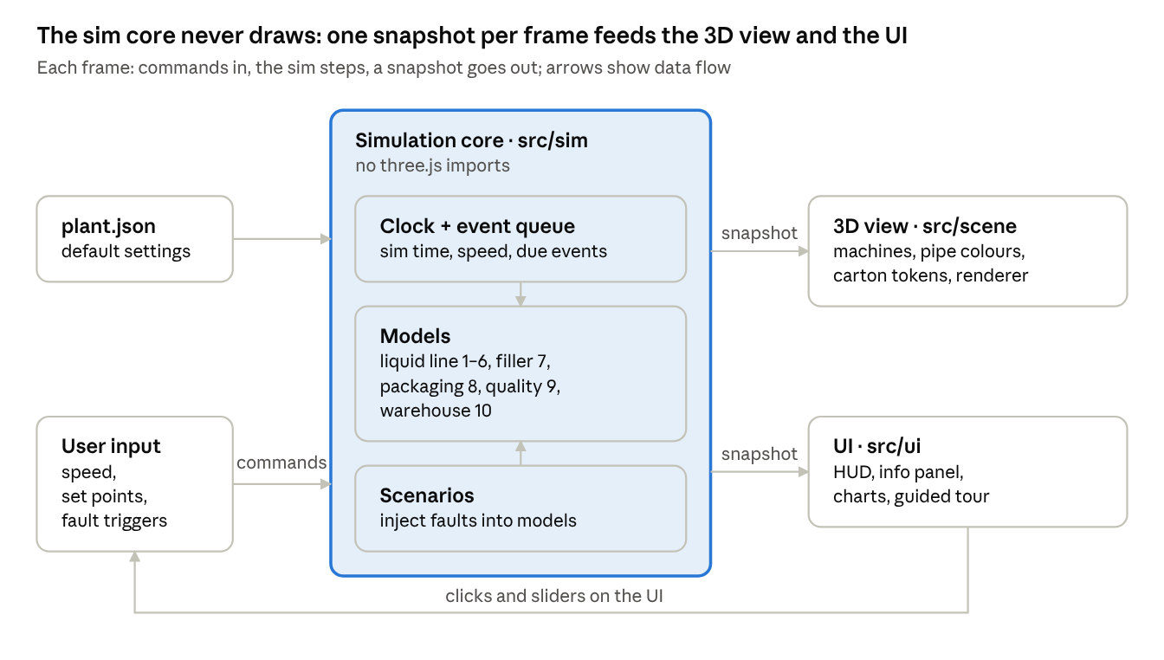
architecture · src/ folders and data flow per frame
Because the core is plain TypeScript with no 3D code, Vitest can test it without a browser.
Folder structure
src/
main.ts boot: load config, start the frame loop
sim/
clock.ts sim time, speed, pause
eventQueue.ts priority queue of timed events
liquidLine.ts stages 1–6: flows, temperatures, levels, F0/B*, divert
filler.ts stage 7: one state machine per filler
packaging.ts stage 8: trays, pallets, SSCC numbers
quality.ts stage 9: batches, samples, incubation
warehouse.ts stage 10: stock, FEFO picking, trucks
scenarios.ts fault injection
scene/
world.ts renderer, lights, floor, cameras
equipment/ one class per machine: build() + update(snapshot)
pipes.ts tubes, flow texture, temperature colour
tokens.ts InstancedMesh cartons, trays, pallets
ui/
hud.ts panel.ts charts.ts tour.ts
data/
plant.json the default settings from the Simulation model section
Every frame
- Turn UI input into commands: speed, set points, scenario triggers.
- Advance the sim: continuous steps, then every event that is due.
- Build a plain-object snapshot of the plant state.
- Update the 3D scene from the snapshot: machines, pipe colours, carton tokens.
- Update the HUD and charts, throttled to 4 times a second.
- Render.
Performance budget
- 60 fps on a mid-range laptop.
- One InstancedMesh per carton, tray and pallet type; merge static pipes and floors.
- One shadow-casting light; bake ambient occlusion into the hero models in Blender.

User interface & interactions
Use one screen: the 3D plant fills the window, a top bar controls time, a left rail jumps between the 10 stages, a right panel explains the selected machine, and a bottom strip shows the KPIs.
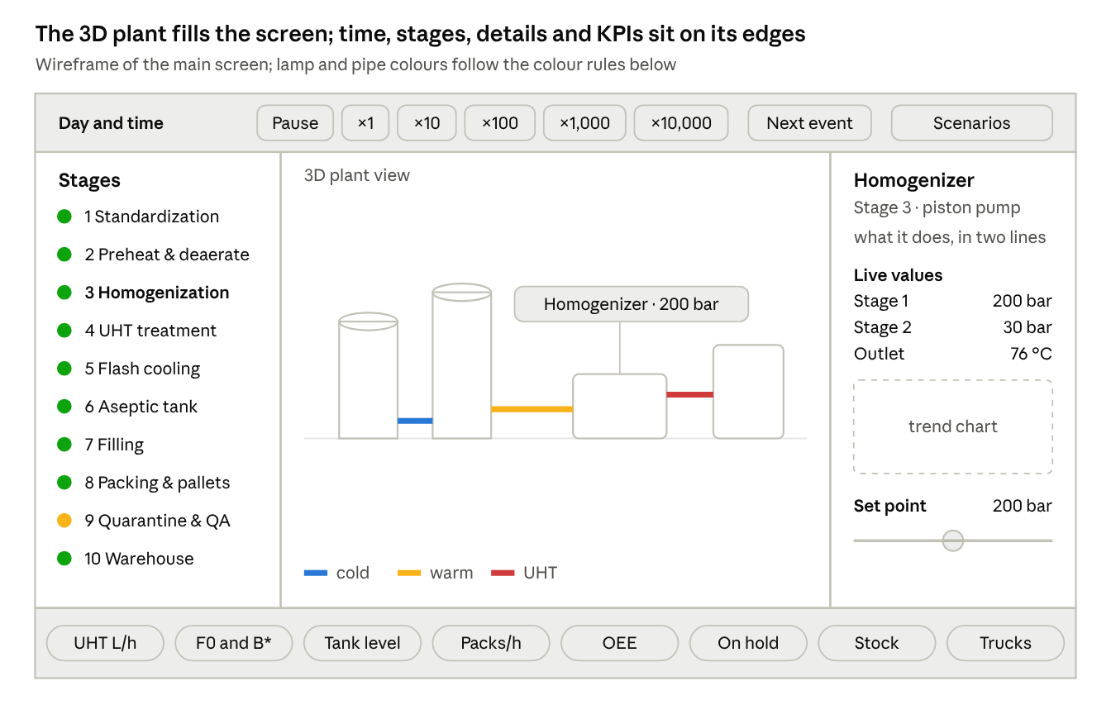
screen wireframe · homogenizer selected, stage 9 on hold
The stage rail and the info panel stay in sync: clicking a machine in 3D selects its stage, and clicking a stage flies the camera to it.
Controls
- Top bar: day and time, pause, speed (×1, ×10, ×100, ×1,000, ×10,000), jump to next event, scenario menu.
- Left rail: stages 1–10, each with a status lamp; a click flies the camera there.
- Right panel: what the machine does (from the stage research), live values, a small trend chart, and sliders for set points that make sense (UHT temperature, filler speed).
- Bottom strip: the KPIs listed under Simulation model.
- In the scene: a floating label with one key value per machine; pipes coloured by temperature with a legend; click a pallet to see its SSCC, batch and status.
Modes
- Free explore: orbit, pan and zoom; double-click a machine to focus on it.
- Guided tour: the camera visits stages 1–10 in order with a two-line caption each, about 3 minutes in total.
- Scenario: pick a fault, watch the plant react, then read a short log of what happened and why.
Colour rules
- Pipes: blue for cold milk, through yellow, to red at UHT temperature.
- Lamps: green for running, amber for on hold or warning, red for stopped or blocked.
- The same three lamp colours apply everywhere, including pallets in quarantine.

Development roadmap
Build in six phases over 12 weeks: grey-box the whole plant first, make the liquid line work, then the packaging and logistics, and only then spend time on detailed models and polish.
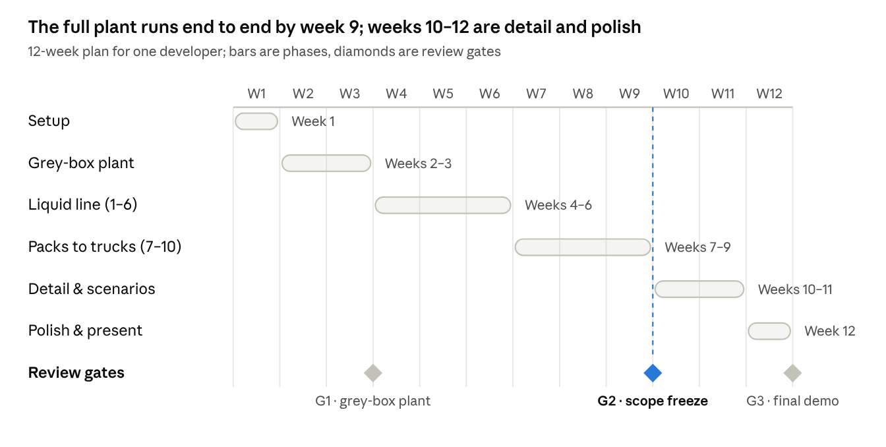
12-week plan · 6 phases, 3 review gates
Gate 2 is the safety net: if the run from silo to truck does not work by week 9, cut Could items instead of stretching the schedule.
Deliverables to tick off
- ☐ Week 1: Vite + three.js project runs; plant.json holds the default settings
- ☐ Week 3 (gate 1): grey-box plant with all seven zones, pipes and camera fly-to
- ☐ Week 6: stages 1–6 live (levels, temperatures, F0 and B*, divert); formula tests pass
- ☐ Week 9 (gate 2): stages 7–10 live (packs, pallets, quarantine, warehouse, trucks); scope frozen
- ☐ Week 11: hero models, six fault scenarios, guided tour
- ☐ Week 12 (gate 3): 60 fps check, demo video, report and presentation
If the term runs past 12 weeks, the stretch list is: animated CIP cleaning, a steam and energy model, a switch between direct and indirect UHT, and a mobile layout.

Risks & simplifications
The biggest risk is scope: ten stages plus detailed 3D is a lot for one person, so every stage gets a working grey-box version before any one stage gets polish.
Risk | Effect | Mitigation
Scope too big for one person | Stages unfinished at the deadline | Grey-box all ten stages by week 3; Must/Should/Could priorities; scope freeze at week 9
Too many objects on screen | Frame rate drops with thousands of packs and pallets | InstancedMesh, merged static meshes, visual tokens instead of one mesh per pack
Time scales from 4 seconds to 6 months | Viewers miss what happens | Speed presets, jump to next event, event log
Stage order mixes plant types | A reviewer questions where the homogenizer sits | Keep the course order and explain it in an "About this model" panel
3D modelling eats the schedule | Simulation logic slips | Only four hero models; primitives and CC0 kits for the rest
Wrong numbers in formulas | Misleading KPIs | Unit tests against hand calculations, such as F0 ≈ 5.2 min at 140 °C for 4 s
Accepted simplifications
- Milk moves as plug flow, with no pressure drop, viscosity effects or fouling.
- Temperatures change in steps with a short lag, not through heat-transfer equations.
- One product and one pack size.
- Cleaning is a timed machine state, not liquid moving through the pipes.
- Failures follow simple random rates, not real plant data.

Sources
Process and regulation
- Tetra Pak Dairy Processing Handbook: Long-life milk
- Tetra Pak Dairy Processing Handbook: Centrifugal separators and milk standardization
- Tetra Pak Dairy Processing Handbook: Deaerators
- Tetra Pak Dairy Processing Handbook: Homogenizers
- Tetra Pak Dairy Processing Handbook: Tanks
- Tetra Pak Dairy Processing Handbook: Mixers
- UHT milk and milk products (INFLIBNET e-PG Pathshala module)
- Regulation (EC) No 853/2004, Annex III, Section IX
- FDA: Aseptic Processing and Packaging for the Food Industry
- Reinheimer & Demkow (1990), Comparison of rapid tests for assessing UHT milk sterility, Journal of Dairy Research
- GEA: Shelf-stable milk
Equipment and logistics
- ICPE: Aseptic packaging system (PDF)
- Tetra Alsafe aseptic tank product description (PDF)
- Tetra Pak A3/Flex filling machine
- Tetra Pak straw applicators
- Tetra Pak Tray Shrink 30
- GS1 UK: Logistics labels and SSCCs
- Eurowag: How many euro pallets fit on a truck
- OEE.com: Calculating OEE
Tools
- three.js releases and three.js manual: Installation
- three.js docs: InstancedMesh, TubeGeometry, CSS2DRenderer, GLTFLoader, OrbitControls
- Kenney Conveyor Kit, lil-gui, Vitest

